**ICP-OES ANALYSIS OF “*VEERA NEER”***

Dr.G.Krishnaveni1 *, Dr. G.EssakkyPandian2

1 PG Scholar, PG-Gunapadam, Govt. Siddha Medical College and Hospital, Palayamkottai

2 Professor & HOD, PG-Gunapadam, Govt. Siddha Medical College and Hospital, Palayamkottai

Abstract

Purified mercuric chloride “*Veeram*” is being used in Siddha system of medicine for curing gastric Ulcer, leprosy, severe *vatha* diseases and venereal diseases, etc. *Veera neer* is used as washing solution for External wounds. The objective of the present study is to detect heavy metals (arsenic, lead, cadmium, mercury) and other elements within the permissible limits as per WHO guidelines present in the *Veera neer*. Here, the solution was subjected to standardization by simultaneous ICP-OES analysis equipment (PERKIN ELMER OPTIMA 5300 DV). This paper revealed the therapeutic safer level of heavy metals and other elements present in *Veera neer*, as per WHO guidelines with the help of simultaneous ICP-OES analysis equipment (PERKIN ELMER OPTIMA 5300 DV).

Keywords: Gastric Ulcer, Leprosy, Severe *Vatha Disease,* Venereal Disease

# Introduction

In modern aspect, the goal of wound cleaning is to remove debris and contaminants from the wound without damaging healthy tissue. Key components of wound care include such measures as debridement, irrigation, and wound cleaning. Appropriate care removes necrotic tissue and reduces wound bioburden to enhance wound healing. Physical cleaning with debridement and irrigation is of documented efficacy.

Wounds may be washed with water, saline, or Ringer's solution or cleaned with active ingredients, such as hydrogen peroxide, sodium hypochlorite, acetic acid, alcohol, ionized silver preparations, chlorhexidine, polyhexanide/betadine solution, or povidone-iodine--the majority of which are locally toxic and of limited or no proven efficacy in enhancing wound healing. Although the consensus opinion is that these topical cleaning agents should not be routinely used, recent clinical evidence suggests that polyhexanide/betaine may be nontoxic and effective in enhancing wound healing. Further well-designed studies are needed.

In Siddha, *Veeram* (Mercuric chloride) was first used as a therapeutic agent for venereal diseases during the middle of the eighteenth century in western countries. But for many centuries the perchloride of mercury has been used in India for the treatment of various disorders. This is as such quite toxic and it should be used only after purification and detoxification. **“*Veera neer”***is used as washing solution of external use.

The literature review reveals so far, no scientific evaluations were carried out this particular preparation. Here the drug was subjected to standardization by simultaneous ICP-OES analysis equipment (PERKIN ELMER OPTIMA 5300 DV) to detect heavy metals (arsenic, lead, cadmium, mercury) and other elements, which should be within the permissible limits as per WHO guidelines.

# Material and methods

The Natural *Veeram* were purchased from country merchant shop, Nagarcoil. The Department of Gunapadam, Govt. Siddha Medical College, Tirunelveli, Tamil Nadu issued authenticate certificate that the above raw materials were genuine one according to the chemical compounds.

**PURIFICATION OF VEERAM:**

* *Veeram (*Raw)
* Soodan (Camphor)

**METHOD OF PURIFICATION:**

Camphor (1.5 gm) is mixed with tender coconut water (2 medium sizes) and placed in a mud pot. *Veeram* (15 gm) is tied in a cloth and hanged over the pot without touching the solution and the pot is burnt for half an hour.

**PREPERATION OF *VEERANEER*:**

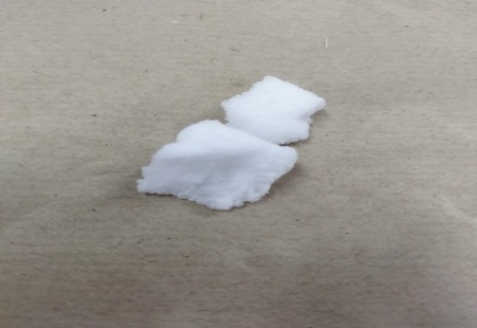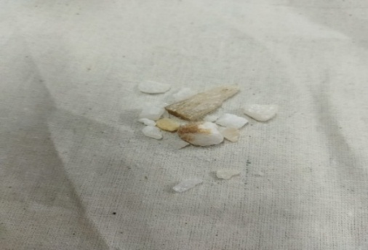Take 65 mg of purified *Veerram* is powdered and mixed with 240 ml of sterile water as per the reference of Gunapadam thathu jeeva vagupu.

**Fig 1. *Veeram* Raw (Unpurified) Fig 2. Camphor**

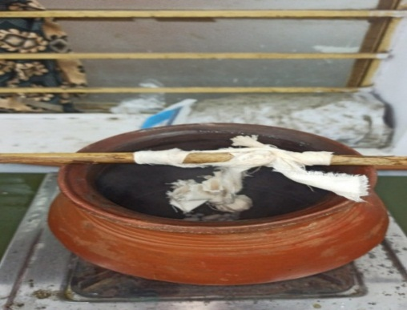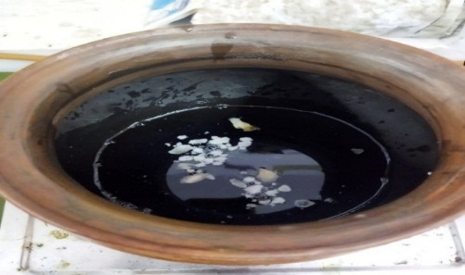 **Fig 3. Tender Coconut Water + Camphor Fig 4. *Veeram* tied in a cloth and hanged over the pot without touching the solution**

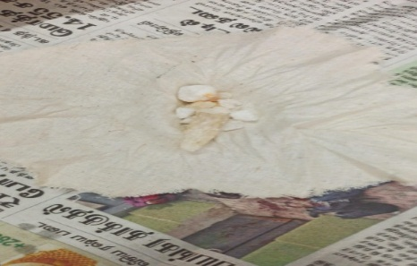  **Fig 5. Purified *Veeram***

# Results and discussion

# ICP-OES Analysis of *Veera neer:*

### Inductively coupled plasma optical emission Spectrometry (ICP-OES)

ICP-OES analysis uesd to detect heavy metals (arsenic, lead, cadmium, mercury) and other elements within the permissible limits as per WHO guidelines.

**Table 1: Elements detected in ICP-OES analysis of *Veera neer (wt: 0.412347 gm)***

|  |  |  |  |
| --- | --- | --- | --- |
| **S.No** | **Elements** | **Wave length** | **Concentration** |
| 1 | Al | 396.152 | BDL |
| 2 | As | 188.979 | BDL |
| 3 | C | 193.03 | 44.123 mg/L |
| 4 | Ca | 315.807 | BDL |
| 5 | Cd | 228.802 | BDL |
| 6 | Cu | 327.393 | BDL |
| 7 | Fe | 238.204 | BDL |
| 8 | Hg | 253.652 | 3.345 mg/L |
| 9 | S | 180.731 | BDL |

BDL- Below Detecting Limit

**CARBON**

Carbon-based nanomaterials emerge as a promising candidate for wound care management applications due to their remarkable mechanical, electrical, thermal, antimicrobial, and regeneration capabilities. They are also capable to reduce the hydrophobicity of composite materials. The size, shape, chemical composition, stability, agglomeration, porosity, and functionalization of carbon-based nanomaterials ensure the successful interaction of nanomaterials with biological molecule.

**MERCURY**

Mercurochrome is an organo-mercury compound in aqueous solution, used to prevent infection in minor wounds. Mercury is useful in antiseptics such as mercurochrome because it acts as a disinfectant, stopping the bacteria from reproducing and spreading.

# Conclusion

According to the result in ICP-OES, FTIR analysis of *“Veeraneer”* has effective action on wounds.

References:

1. Dr.Kuppusamy Mudaliyar. K. N, H.P.I.M, Dr. K.S. Utham-marayan, H.P.I.M, Siddha vaithiya thirattu, Indian medicine and Hemoepathy, 3rd edition,2009, pg 305.
2. Dr.Thiyagarajan.R,L.IM Gunapadam thathu jeeva vaguppu, Indian medicine and homeopathy,7th edition,2009, pg 294.
3. Sambasivam pillai.T.V (1931), Tamil-English Dictionary, Madras: The Research Institute of Siddhar’s science.
4. Kuppusamy muthaliyar (1998), Siddha vaithiya thiratu, Indian Medicine and Homeopathy Chennai; 1st edition.
5. Dr.Sornamaariyammaal.I,M.D(S), Gunapadam thathu jeeva vaguppu,Indian medicine and homeopathy, Chennai-600 106.
6. [https://www.vedantu.com/question-answer/the-halo-compound-of-methane-used-as-fire class-11-chemistry-cbse-5f93bc2ee18dd7407e461f83](https://www.vedantu.com/question-answer/the-halo-compound-of-methane-used-as-fire%20class-11-chemistry-cbse-5f93bc2ee18dd7407e461f83).