## **Health Hygiene**

* **ABOUT MYSELF :-**

Ashutosh K. Joshi

3rd Year BAMS

RK University Ayurvedic College and Hospital

Rajkot, Gujarat.

* **ABSTRACT** **:-**
* In modern times, it has become so important to take care of one’s health and hygiene.
* With the rising population levels, pollution levels, emission of harmful gases, it has to be a priority for everyone to maintain their health and hygiene.
* The health and hygiene essay guides you the different ways into which a person should be aware of their life.
* **KEYWORD :-**

Health Hygiene, Personal Hygiene, Environmental Hygiene, WHO, Health, Clean.

* **INTRODUCTION :-**
* Cleanliness is one of the most important practice for a clean and healthy environment.
* It may be related to public hygiene or personal hygiene. It is essential for everyone to learn about cleanliness, hygiene, sanitation and the various diseases that are caused due to poor maintenance of hygienic conditions.
* The habits which are learnt or followed at a young age, get embedded into one's personality. One should start to follow certain habits like washing hands before meals, regular brushing of teeth, and bathing from the young age.
* It is essential to follow certain good practices like keeping our surroundings clean, avoiding littering in public places, refraining from spitting on the road, and many more good habits.
* 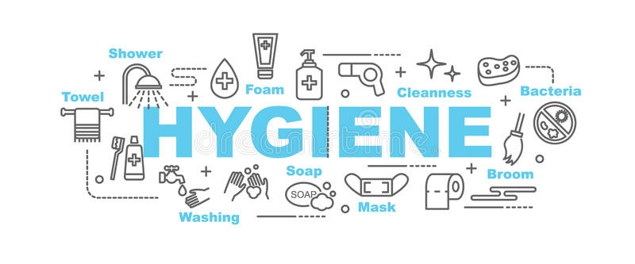Awareness of the Cleanliness and Personal Hygiene is the need of the hour in Our country where the diseases like Dengue fever, swine flu, malaria, chicken fox and jaundice are fast spreading. People should realise the importance of cleanliness and personal hygiene to prevent themselves from these diseases.
* **BACKGROUND OF HEALTH HYGIENE :-**
* The word Hygiene is derived from **Hygeia**, the goddess of health in Greek mythology. She is represented as a beautiful woman holding in her hand a bowl from which a serpent is drinking. In the Greek mythology, the serpent testifies the art of healing.
* Hygiene is a concept related to cleanliness, health and medicine. It is as well related to personal and professional care practices. In medicine and everyday life settings, hygiene practices are employed as preventive measures to reduce the incidence and spreading of disease.
* The terms [cleanliness](https://en.m.wikipedia.org/wiki/Cleanliness) and hygiene are often used interchangeably, which can cause confusion. In general, hygiene refers to practices that prevent spread of disease-causing organisms. Cleaning processes (e.g., hand washing) remove infectious microbes as well as dirt and soil, and are thus often the means to achieve hygiene.
* Other uses of the term appear in phrases including body hygiene, personal hygiene, [sleep hygiene](https://en.m.wikipedia.org/wiki/Sleep_hygiene), [mental hygiene](https://en.m.wikipedia.org/wiki/Mental_hygiene), [dental hygiene](https://en.m.wikipedia.org/wiki/Oral_hygiene), and [occupational hygiene](https://en.m.wikipedia.org/wiki/Occupational_hygiene), used in connection with [public health](https://en.m.wikipedia.org/wiki/Public_health). Hygiene is also the name of a branch of science that deals with the promotion and preservation of health.

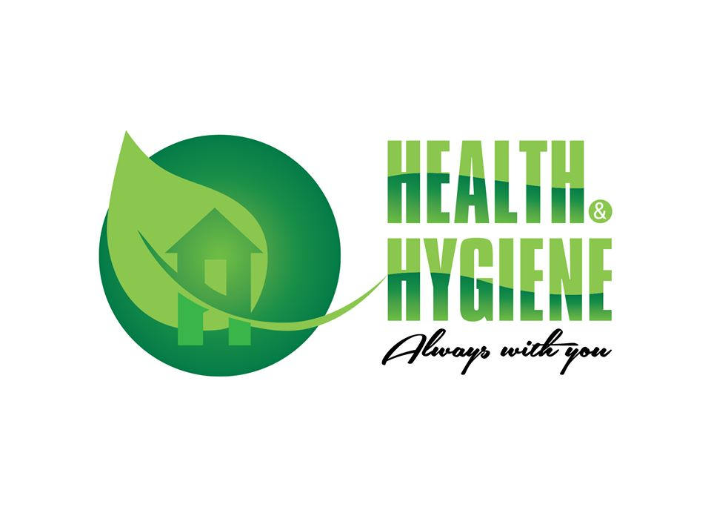

* **REAL INFORMATION OF HEALTH HYGIENE :-**
* According to WHO, health is a state of complete mental, spiritual, physical, and social wellbeing and not only the absence of disease. If a person is in a good physical state and free from any diseases but is under constant stress, greed, tension, anger, etc., then that person is not healthy.
* For the human body, health is a positive state where every part of the mind and body is in harmony. Additionally, it is also functioning and balancing the other parts.
* Thus, in other words, when all parts of the body are functioning well, this physical well-being state of the human body is called health. It is well said and proved that a healthy person is someone who has a sound body and a sound mind.
* Health is one of the characteristics of life that helps a person live longer.
* Hygiene refers to good practices and rituals that prevent diseases and leads to good health. Thus, it mainly includes proper sewage disposal, cleanliness, and safe drinking water supply.
* So, it includes all the activities that are done for preserving and improving as well as maintaining sound health.
* **Types of hygiene:-**
* Two types – 1. Personal hygiene

1. Environmental hygiene.
2. **Personal Hygiene -**

* The aim of personal hygiene is to promote standards of personal cleanliness, within the setting of the condition where people live. Personal hygiene includes [bathing](http://ecoursesonline.iasri.res.in/mod/page/view.php?id=20330), clothing, washing hands and toileting, care of nails, feet, teeth, spitting, coughing, sneezing, personal appearance, and inculcation of clean habits when young.

### **Toilet Hygiene :**

* 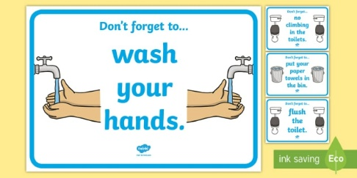Wash your hands after you use the restroom. Scrub with soap for 20 to 30 seconds, and be sure to clean between your fingers, on the back of your hands, and under your nails. Rinse with warm water, and dry with a clean towel.
* If you don’t have running water or soap, an alcohol-based hand sanitizer will also work. Use one that’s at least 60 percent alcohol.

### **Shower Hygiene :**

* Personal preference may dictate how often you wish to shower, but most people will benefit from a rinse at least every other day. Showering with soap helps rinse away dead skin cells, bacteria, and oils.
* You should also [**wash your hair**](https://www.healthline.com/health/beauty-skin-care/how-often-should-you-wash-your-hair) at least twice a week. Shampooing your hair and scalp helps remove skin build-up and protects against oily residues that can irritate your skin.

### **Nail Hygiene :**

### Trim your nails regularly to keep them short and clean. Brush under them with a nail brush or washcloth to rinse away build-up, dirt, and germs.

* Tidying your nails helps you prevent spreading germs into your mouth and other body openings. You should also avoid [**biting your nails**](https://www.healthline.com/health/how-to-stop-biting-your-nails).

### **Teeth Hygiene :**

* Good [**dental hygiene**](https://www.healthline.com/health/dental-and-oral-health/best-practices-for-healthy-teeth) is about more than just pearly white teeth. Caring for your teeth and gums is a smart way to prevent [**gum diseases**](https://www.healthline.com/health/gingivitis) and [**cavities**](https://www.healthline.com/health/dental-oral-health-cavities).

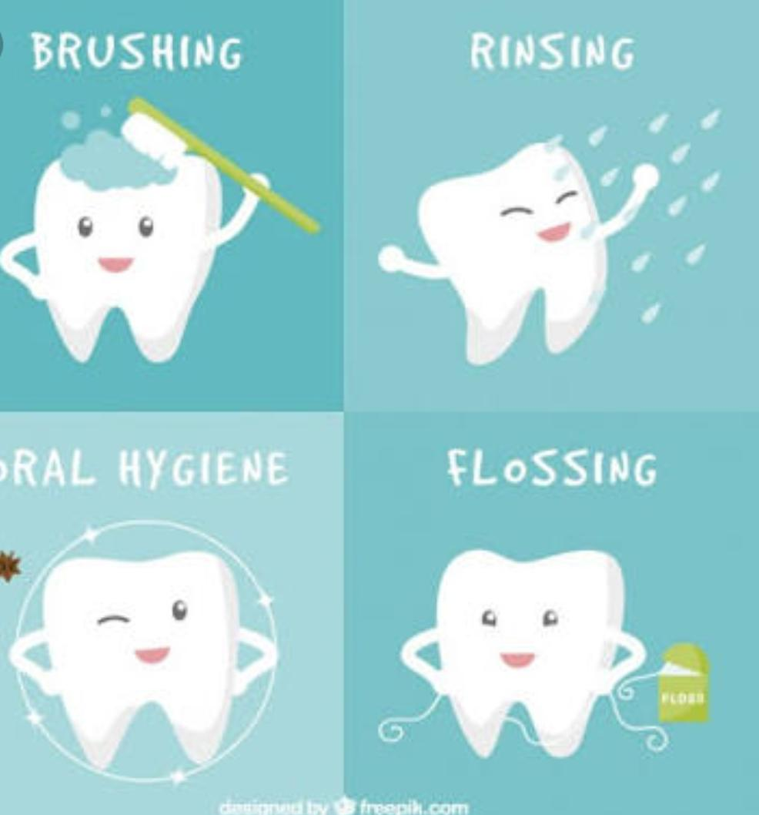

* Brush at least twice a day for 2 minutes. Aim to brush after you wake up and before bed. If you can, brush after every meal, too. Floss between your teeth daily, and ask your dentist about using an antibacterial mouthwash.
* These two steps can help prevent tooth decay and eliminate pockets where bacteria and germs can build up.

### **Sickness Hygiene :**

* 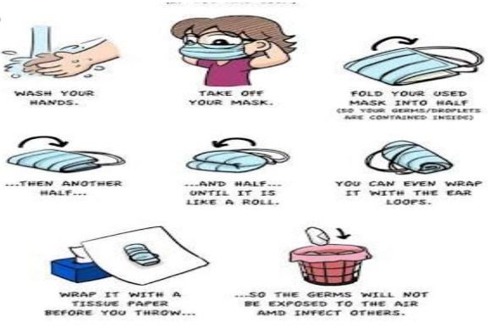If you’re not feeling well, you should take steps to keep from spreading germs to others. This includes covering your mouth and nose when sneezing, wiping down shared surfaces with an antibacterial wipe, and not sharing any utensils or electronics. Also, immediately throw away any soiled tissues.

### **Hand Hygiene :**

* 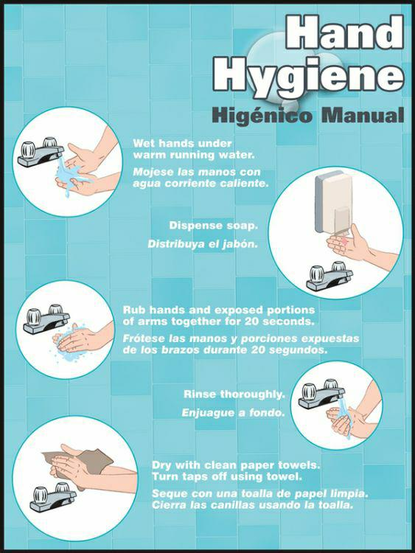Germs on your hands can easily enter your body through your mouth, nose, eyes, or ears.

* Wash your hands -
* when you handle food
* before you eat
* if you handle garbage
* when you sneeze
* any time you touch an animal.

**2. Environmental Hygiene :-**

* Two types – a. Domestic hygiene

b. Community hygiene

* **Domestic Hygiene :**
* 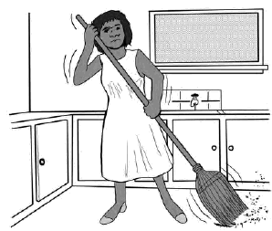Domestic hygiene comprises of home, use of soap, need of fresh air, light, ventilation, hygiene in [storage](http://ecoursesonline.iasri.res.in/mod/page/view.php?id=20636) of food, disposal of waste, avoidance of household pests, rats, mice, insects.
* **Community Hygiene :**

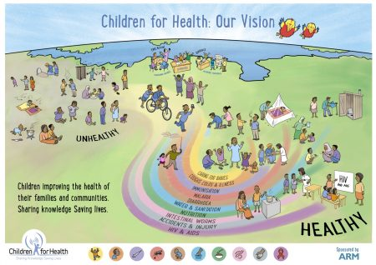

* It includes safe disposal of human excreta, control of vectors responsible for transmission of diseases, control of air and [water pollution](http://ecoursesonline.iasri.res.in/mod/page/view.php?id=20626).
* **IMPACT OF HEALTH HYGIENE ON SOCIETY :-**

### **Disease Prevention :**

* Good hygiene lowers your risk for diseases and illnesses commonly spread through viruses and bacteria. Your hands come into contact with bacteria every time you [***cough***](https://www.solvhealth.com/health-a-z/cough), use the restroom, touch your pet, or touch surfaces, such as stair railings, used frequently by others.
* Failing to wash your hands and body regularly can cause this bacteria to multiply, increasing the risk for infection and other health problems. Washing yourself and staying clean can kill and remove illness-causing bacteria from your body, lowering the risk for disease.
* Good hygiene is key to preventing infection when wounds and skin irritation are present. Poor hygiene can result in dirt and other bacteria entering and staying inside skin wounds, while good hygiene can ward off this bacteria to prevent infection.
* Good hygiene prevents you from spreading bacteria and disease to others, including co-workers and family members.

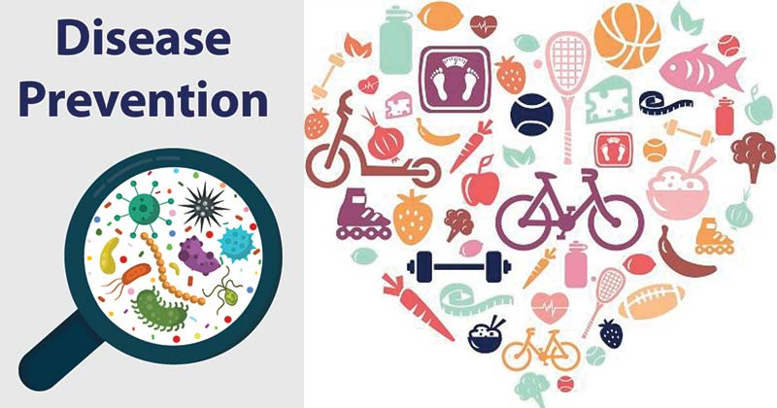

### **2. Social and Professional Acceptance :**

* Spending time around those who fail to demonstrate good hygiene can be unpleasant due to factors such as bad breath and body odour, and it increases your own risk for disease and infection. Poor hygiene can have negative consequences on your social life and relationships — including business relationships.
* Many employers urge or require employees to practice good hygiene and tend to hire people who look clean and as though they practice healthy hygiene habits. Good hygiene is especially important to employers in the food and medical industries, as poor hygiene can lead to contamination and the spread of disease.
* Children who practice good hygiene can avoid being bullied at school, as evidence suggests that poor hygiene is one of the top reasons kids are bullied Parents who teach their children the importance of good hygiene in still healthy habits early on in life and prevent them from experiencing problems with bullies.
* Good hygiene is crucial to good overall health and wellness because it helps lower the risk for disease, illness, and medical conditions caused by the effects of poor hygiene. When a person doesn’t practice good hygiene, their body can accumulate bacteria that contribute to diseases such as athlete’s foot, [head lice](https://www.solvhealth.com/health-a-z/head-lice), and scabies.
* Poor hygiene can also cause parasites to grow and multiply on the skin and in the body, causing parasitic diseases like malaria and toxoplasmosis.
* 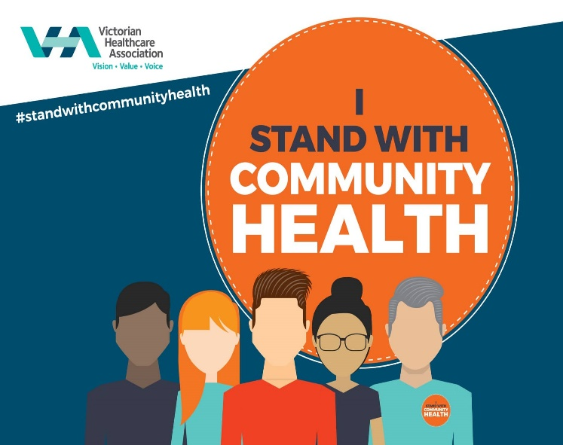Good personal hygiene habits include brushing your teeth, bathing or showering, and wearing clean clothes. Performing these habits daily or as often as needed achieves and maintains good hygiene and cleanliness.
* **REFERENCES :-**
* <https://www.open.edu/openlearncreate/mod/oucontent/view.php?id=187&printable=1>
* <http://oer.nios.ac.in/wiki/index.php/Health_and_Hygiene>
* <https://en.m.wikipedia.org/wiki/Hygiene>
* <https://www.who.int/gpsc/5may/tools/9789241597906/en/>
* <https://www.aise.eu/our-industry/health-and-hygiene.aspx>
* <http://ecoursesonline.iasri.res.in/mod/page/view.php?id=20308>
* <https://www.solvhealth.com/health-a-z/good-hygiene>
* <https://www.healthline.com/health/personal-hygiene>
* <https://www.medicalnewstoday.com/articles/personal-hygiene>

